AI-HEALTHCARE SYSTEM

PROJECT OVERVIEW
The AI Healthcare System is designed to assist medical professionals in early disease detection and structured treatment guidance through intelligent predictive analytics. In healthcare environments, timely identification of critical conditions such as sepsis and brain tumors is essential for reducing complications and improving patient outcomes. Manual analysis of clinical parameters and medical images can be time-consuming and subject to variability. This project addresses these challenges by integrating Machine Learning for structured clinical data analysis, Deep Learning for MRI-based tumor detection, and rule-based logic for treatment recommendation.
The system continuously evaluates patient clinical features and medical images to predict disease risk, classify severity, and provide actionable treatment suggestions. Acting as a clinical decision-support assistant rather than replacing medical professionals, the platform empowers healthcare providers with data-driven insights, structured probability scores, and organized patient history tracking. By combining predictive modeling, database management, and interactive visualization, the AI Healthcare System promotes informed clinical decisions, structured monitoring, and improved healthcare workflow efficiency.

Scenario 1: Early Sepsis Risk Detection
● Patient presents with abnormal vitals and laboratory values
● ML model analyzes 43 structured clinical features
● System predicts probability of sepsis
The assistant explains:
“You show elevated clinical indicators associated with sepsis risk. Immediate monitoring and further evaluation are recommended.”
By detecting early warning signs, the system enables proactive intervention before the condition becomes critical.

Scenario 2: MRI-Based Tumor Detection
● Patient uploads MRI brain scan
● CNN model analyzes image patterns
● Model detects abnormal tissue region
The assistant displays:
“Tumor Detected with 87% confidence. Further radiological evaluation is recommended.”
This supports medical professionals with automated image analysis and confidence scoring for diagnostic assistance.

Scenario 3: Severity-Based Treatment Guidance
● Disease identified as Sepsis
● Severity level selected as High
● System generates structured treatment recommendation
The assistant suggests:
“Immediate ICU admission is recommended. Begin broad-spectrum IV antibiotics and fluid resuscitation.”
This provides consistent, severity-mapped medical guidance aligned with predicted risk levels.

Overview
The AI Healthcare System is designed to support healthcare providers with predictive modeling and structured patient monitoring. Early identification of life-threatening conditions such as sepsis and accurate interpretation of MRI scans are crucial in modern clinical settings. This system predicts disease risk and provides severity-based treatment recommendations to enhance medical decision-making.
The Sepsis Prediction module uses a trained Machine Learning classification model (Scikit-learn) due to its effectiveness in handling structured clinical datasets. It takes inputs such as vital signs, lab values, and diagnostic indicators (43 features) to predict whether a patient is at risk of sepsis. By continuously evaluating these parameters, the system can forecast clinical deterioration and highlight potential medical concerns.
The Tumor Detection module utilizes a Convolutional Neural Network (CNN) built with TensorFlow to analyze MRI images. The model processes image data, identifies abnormal patterns, and generates confidence-based classification outputs.
Beyond predictions, the system also provides structured treatment recommendations using rule-based severity mapping. Acting as a clinical support assistant rather than replacing medical expertise, the platform enhances transparency, supports informed decision-making, and maintains structured patient records for future review.
1. Data Preprocessing Layer
• Cleans and validates structured clinical input data
• Ensures correct formatting of the 43 clinical features
• Performs image preprocessing for MRI inputs (resizing, normalization)
• Maintains consistent transformation pipeline for both training and inference using NumPy and TensorFlow
2. Model Training Layer (Offline Engine)
• Sepsis Model: Trained using Scikit-learn classification algorithms
• Tumor Model: Trained using Convolutional Neural Network (CNN) architecture in TensorFlow
• Evaluates model performance using metrics such as Accuracy, Precision, Recall, and Confidence Scores
• Saves trained models (sepsis_model.pkl, brain_tumor_model.keras) for production use
3. Model Storage & Management
• Stores trained ML and DL models for real-time inference
• Maintains model version tracking for reproducibility
• Enables seamless loading of models in FastAPI environment
• Ensures consistency between development and production usage
4. Prediction & Inference Layer (Online Engine)
• Loads trained models into memory for real-time predictions
• Receives patient-specific input via REST API
• Applies validation and preprocessing
• Predicts disease risk (Sepsis / Tumor Detection)
• Generates severity-based treatment recommendations
• Stores patient predictions and history in database
• Logs system activity for monitoring and auditability
5. User Interface Layer (Streamlit Frontend)
• Users enter patient name, age, and gender
• Provides input forms for clinical data (Sepsis)
• Allows MRI image upload (Tumor Detection)
• Displays prediction results with confidence scores
• Shows severity-based treatment recommendations
• Enables patient history viewing and tracking

6. Output & Reporting
• When patient data is submitted, the system evaluates disease risk
• ML model predicts sepsis probability based on 43 features
• CNN model analyzes MRI images and detects tumor presence
• Rule-based module generates structured treatment guidance
• Results are displayed with probability/confidence indicators
• All predictions and recommendations are stored with timestamps
• The system acts as a clinical decision-support tool, assisting healthcare providers in making informed and timely decisions

Technologies Used
Scikit-Learn (Machine Learning – Sepsis Model)
• A powerful Python machine learning library used for classification and predictive modeling.
• In this project, it is used to build the Sepsis Prediction model based on 43 structured clinical features.
• The model predicts whether a patient is at risk of sepsis and calculates probability scores.
• Chosen for its reliability, performance on structured medical datasets, and strong evaluation tools.
TensorFlow (Deep Learning – Tumor Detection Model)
• An open-source deep learning framework used for building neural networks.
• In this project, it powers the Convolutional Neural Network (CNN) for MRI-based brain tumor detection.
• Processes medical images, performs feature extraction, and predicts tumor presence with confidence scores.
• Suitable for handling image classification tasks in healthcare environments.

Pandas
• A Python library for data manipulation and analysis.
• Used to clean and structure clinical datasets during preprocessing and model development.
• Helps manage patient records, transform input data, and organize prediction history.
• Useful for converting API responses into tabular formats for frontend visualization.

NumPy
• A numerical computing library used for handling arrays and mathematical operations.
• Used to convert clinical features into numerical arrays for model input.
• Supports image preprocessing steps such as normalization and reshaping for CNN inference.
• Ensures efficient numerical computation during real-time predictions.

SQLAlchemy
• An Object Relational Mapping (ORM) library for database interaction.
• Used to define database models for SepsisRecord, TumorRecord, and TreatmentRecord.
• Enables structured storage of patient details, predictions, confidence scores, and timestamps.
• Ensures seamless communication between the FastAPI backend and SQLite database.

SQLite (Database System)
• A lightweight relational database used for structured data storage.
• Stores patient information, prediction history, and treatment recommendations.
• Enables real-time retrieval of patient records through history endpoints.
• Suitable for small to medium-scale healthcare applications and local deployments.

FastAPI (Backend Framework)
• A high-performance Python web framework for building REST APIs.
• Handles API routing, request validation, authentication, and model inference.
• Serves endpoints for:
- Sepsis Prediction
- Tumor Detection
- Treatment Recommendation
- Patient History Retrieval
• Supports API key-based authentication for secure access.

Streamlit (Frontend Framework)
• A Python framework for building interactive web applications.
• Provides a user-friendly interface for entering patient details and clinical inputs.
• Displays prediction results, probability scores, treatment recommendations, and history tables.
• Enables real-time interaction between users and the AI system.

Logging System
• Custom logging configuration implemented using Python logging module.
• Records API calls, prediction results, errors, and system events.
• Helps monitor system performance and maintain audit trails in healthcare workflows.
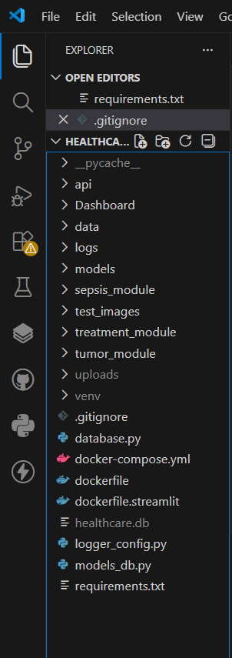

MILESTONE–1: Environment Setup

Activity 1.1: Python Environment & Virtual Environment Setup
- Installed Python 3.10+ on the system to ensure compatibility with FastAPI, TensorFlow, and Scikit-learn.
- Opened Visual Studio Code (VS Code) and navigated to the project directory:
cd "D:\MACHINE LEARNING PROJECTS\healthcare_ai_system"
- Created a virtual environment to isolate project dependencies:
python -m venv venv
- Activated the virtual environment:
venv\Scripts\activate
- Installed all required project dependencies:
pip install -r requirements.txt
This ensured a clean, reproducible environment for backend development, model integration, and frontend deployment.

Activity 1.2: Project Folder Structure
A modular and scalable project structure was created to separate backend, frontend, models, and database components.
Root Project Directory:
healthcare_ai_system/
Core Folders Created:
api/
• Contains FastAPI backend logic
• Includes main.py for API endpoints
• Handles model inference and database operations
models/
• Stores trained ML and DL models
• sepsis_model.pkl
• brain_tumor_model_clean.keras

Dashboard/
• Contains Streamlit frontend application
• app.py for UI and visualization
• Displays predictions, confidence scores, and patient history
data/
• Stores structured datasets used for model training
• Clinical datasets for Sepsis model
uploads/
• Stores uploaded MRI images for tumor detection
logs/
• Contains system log file (app.log)
• Tracks API requests, predictions, and errors

Core Python Files Created in Root Directory
• database.py → Database connection configuration (SQLite + SQLAlchemy)
• models_db.py → ORM models (SepsisRecord, TumorRecord, TreatmentRecord)
• logger_config.py → Logging configuration
• requirements.txt → Project dependencies

Model Development Notebooks (Optional Development Phase)
notebooks/
• model_building_sepsis.ipynb
• tumor_model_training.ipynb
• Used for:
- Data preprocessing
- Model training
- Performance evaluation
- Model export to production format
This structured environment setup ensured:
• Clean dependency management
• Modular backend and frontend separation
• Organized storage of models and datasets
• Scalable architecture for future enhancements

MILESTONE–2: Model Building

Activity 2.1: Sepsis Prediction Model Development (Machine Learning)
• Imported required libraries for data handling, preprocessing, model training, and evaluation using Pandas, NumPy, and Scikit-learn.
• Loaded the prepared clinical dataset containing 43 structured medical features and the target label (Sepsis: 0 or 1).
• Verified dataset structure, handled missing values, and ensured numeric feature formatting.
• Separated dataset into:
- Features (X – 43 clinical indicators)
- Target variable (y – Sepsis Risk)
• Split the dataset into training and testing sets using train_test_split to evaluate performance on unseen data.
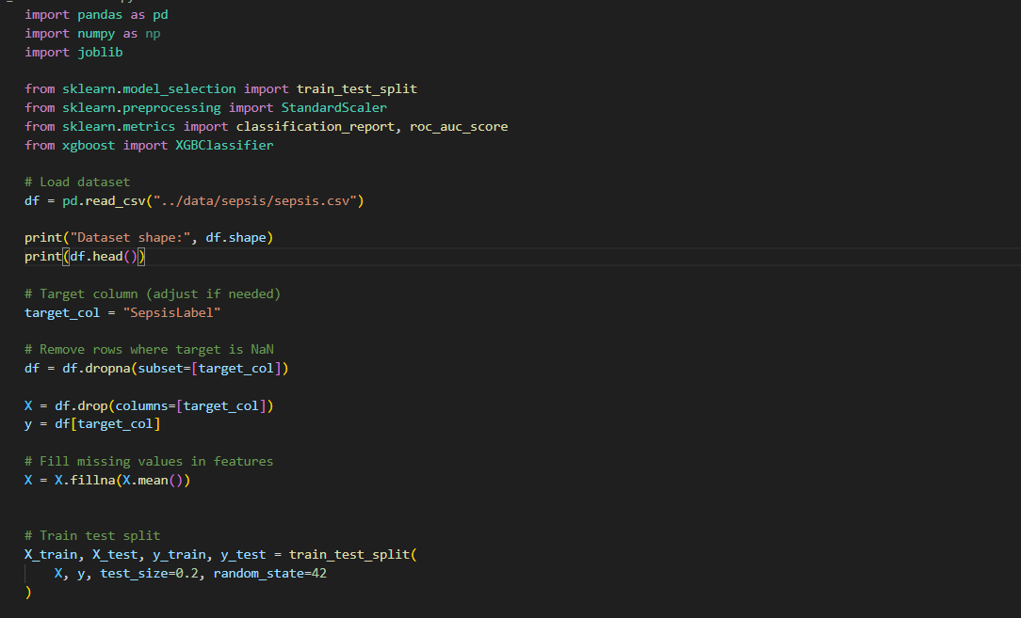
• Used a fixed random_state to ensure reproducible results.
• Verified training feature set (X_train) to confirm correct feature selection.
• Inspected training labels (y_train) to confirm correct binary mapping.
Model Training
• Imported classification algorithms from Scikit-learn.
• Initialized the selected classifier for structured medical data.
• Trained the model using X_train and y_train.
• Evaluated performance using:
- Accuracy
- Precision
- Recall
- F1-score
- Confusion Matrix
• Achieved high accuracy, indicating strong pattern learning for early sepsis detection.
• Saved the trained model using joblib as:
sepsis_model.pkl
• This model is later loaded into FastAPI for real-time predictions.

Activity 2.2: Tumor Detection Model Development (Deep Learning)
• Imported TensorFlow and Keras libraries for deep learning model building.
• Loaded MRI image dataset for tumor classification.
• Performed image preprocessing:
- Image resizing (224x224)
- Normalization
- Label encoding
• Built a Convolutional Neural Network (CNN) architecture for image classification.
• Trained the CNN model on labeled MRI images.
• Evaluated model performance using:
- Accuracy
- Validation loss
- Confidence scores
• Saved the trained deep learning model as:
brain_tumor_model_clean.keras
• This model is later loaded into FastAPI for real-time inference.

MILESTONE–3: Database Integration (SQLite)
• Connected Python to SQLite using SQLAlchemy ORM.
• Created structured database tables:
- SepsisRecord
- TumorRecord
- TreatmentRecord
• Defined fields such as:
- Patient name
- Age
- Gender
- Prediction result
- Confidence/Probability
- Timestamp
• Used Base.metadata.create_all() to initialize database.
• Confirmed successful creation of healthcare.db.

MILESTONE–4: Streamlit Frontend (Dashboard/app.py)
The Streamlit application builds the interactive frontend of the AI Healthcare System.
It connects to the FastAPI backend, allows patient data entry, uploads MRI scans, generates predictions, and displays history records.
Frontend UI Features
• Configures Streamlit page with:
- Title
- Icon
- Wide layout

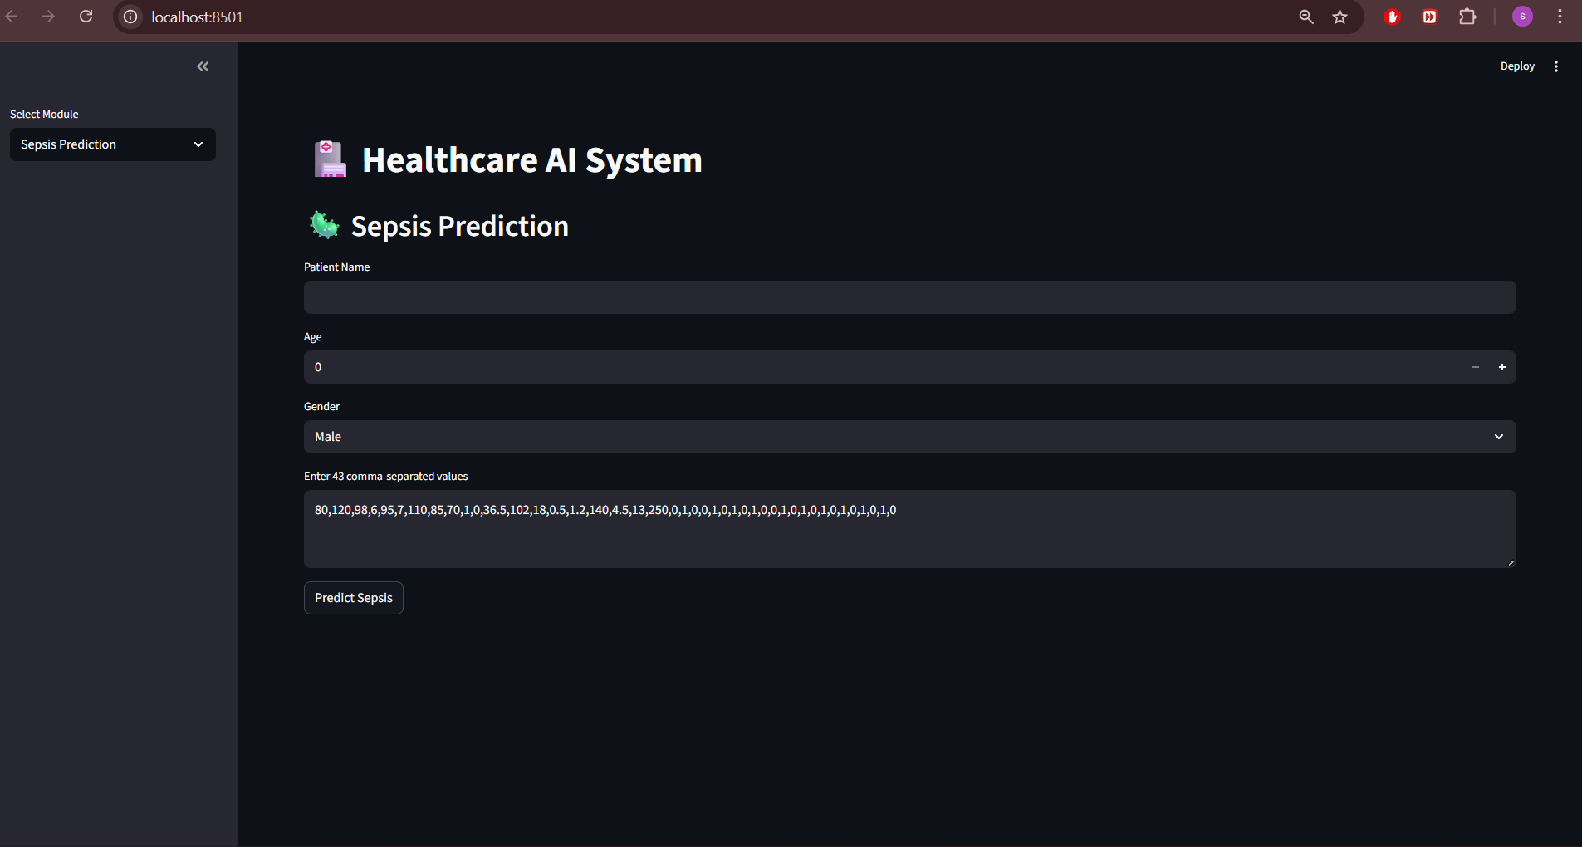
• Injects custom CSS using st.markdown for improved UI styling.
• Creates sidebar navigation:
- Sepsis Prediction
- Tumor Detection
- Treatment Recommendation
- View History
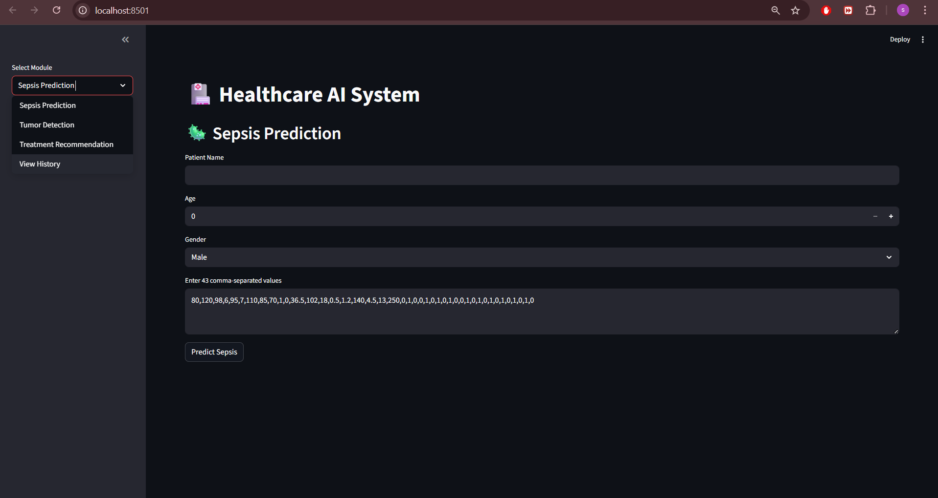
Sepsis Module (Frontend)
• Accepts patient details:
- Name
- Age
- Gender
- 43 Clinical Features
• Sends data to FastAPI using POST request.
• Displays:
- Risk status (High/Low)
- Model confidence percentage
- Visual progress bar

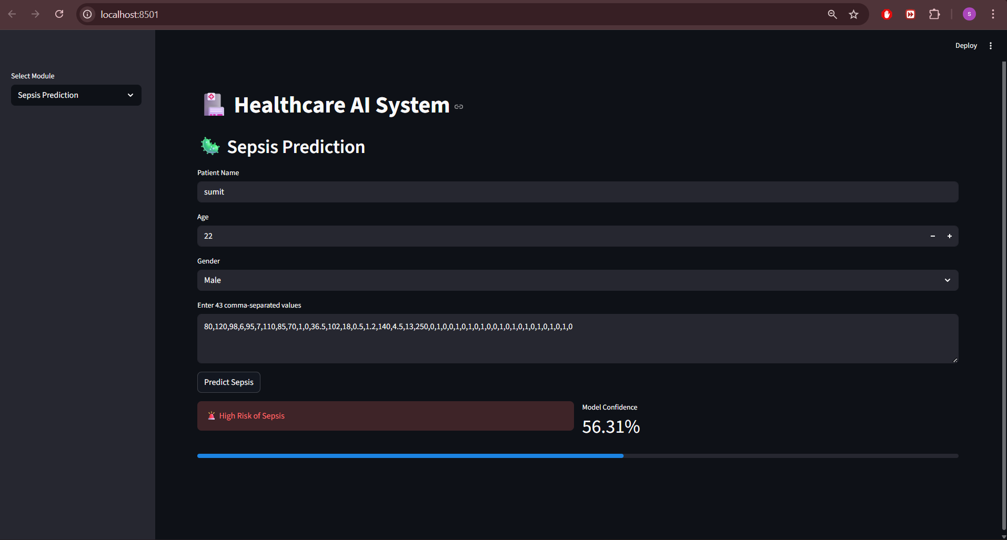

Tumor Module (Frontend)
• Accepts:
- Patient details
- MRI image path
• Sends request to /predict-tumor endpoint.
• Displays:
- Tumor Detected / No Tumor
- Confidence score
- Image-based diagnostic result

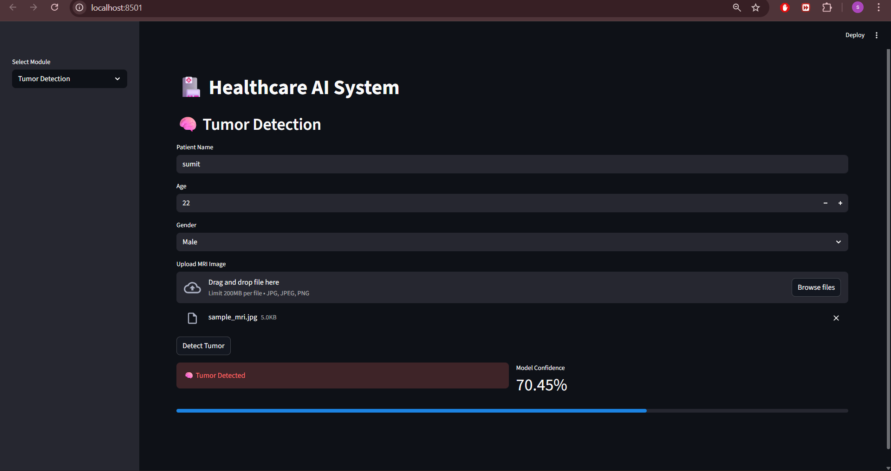

Treatment Recommendation Module
• Accepts:
- Disease type
- Severity level
• Displays:
- Recommended action
- Treatment plan
- Urgency level

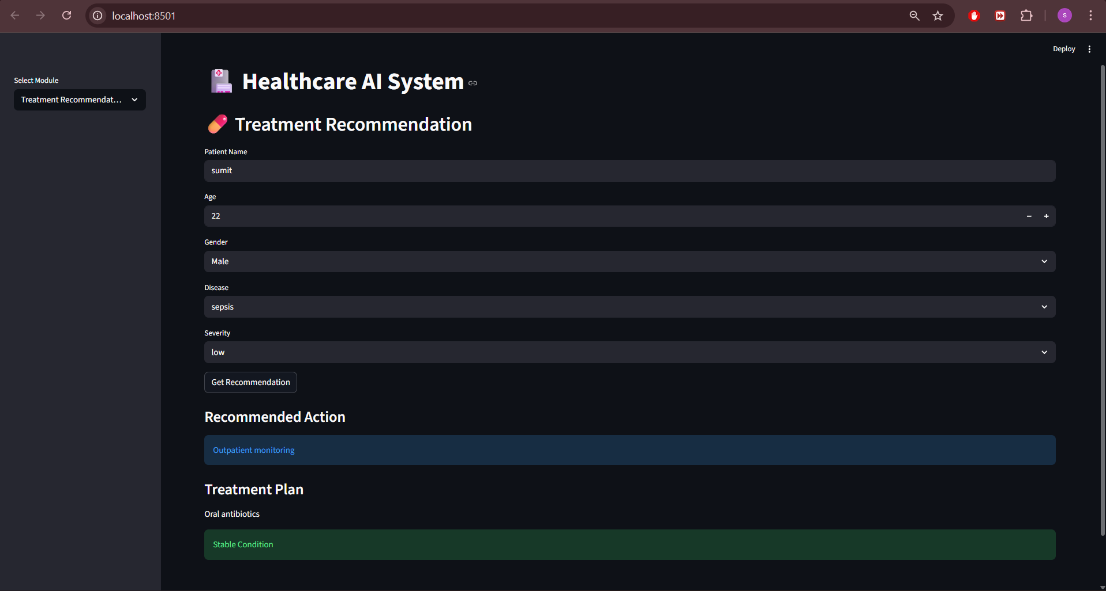

History Viewer
• Fetches prediction records from database.
• Displays patient history in table format.
• Allows filtering by:
- Sepsis
- Tumor
- Treatment
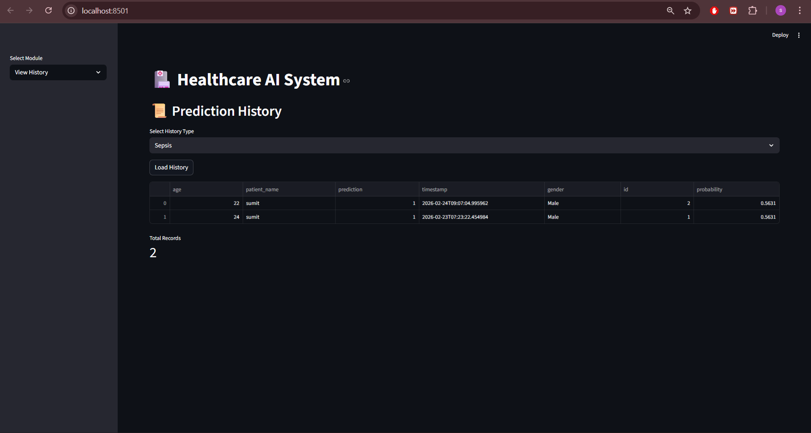

MILESTONE–5: Backend Development (FastAPI)
The FastAPI backend manages:
• API routing
• Model inference
• Database operations
• Authentication (API key)
• Logging
• Error handling

Backend Functionalities
• Imports FastAPI and Pydantic for API and validation.
• Loads ML model (sepsis_model.pkl) using joblib.
• Loads CNN model (brain_tumor_model_clean.keras) using TensorFlow.
• Implements API key authentication using Security dependency.
• Defines request schemas for:
- Sepsis
- Tumor
- Treatment

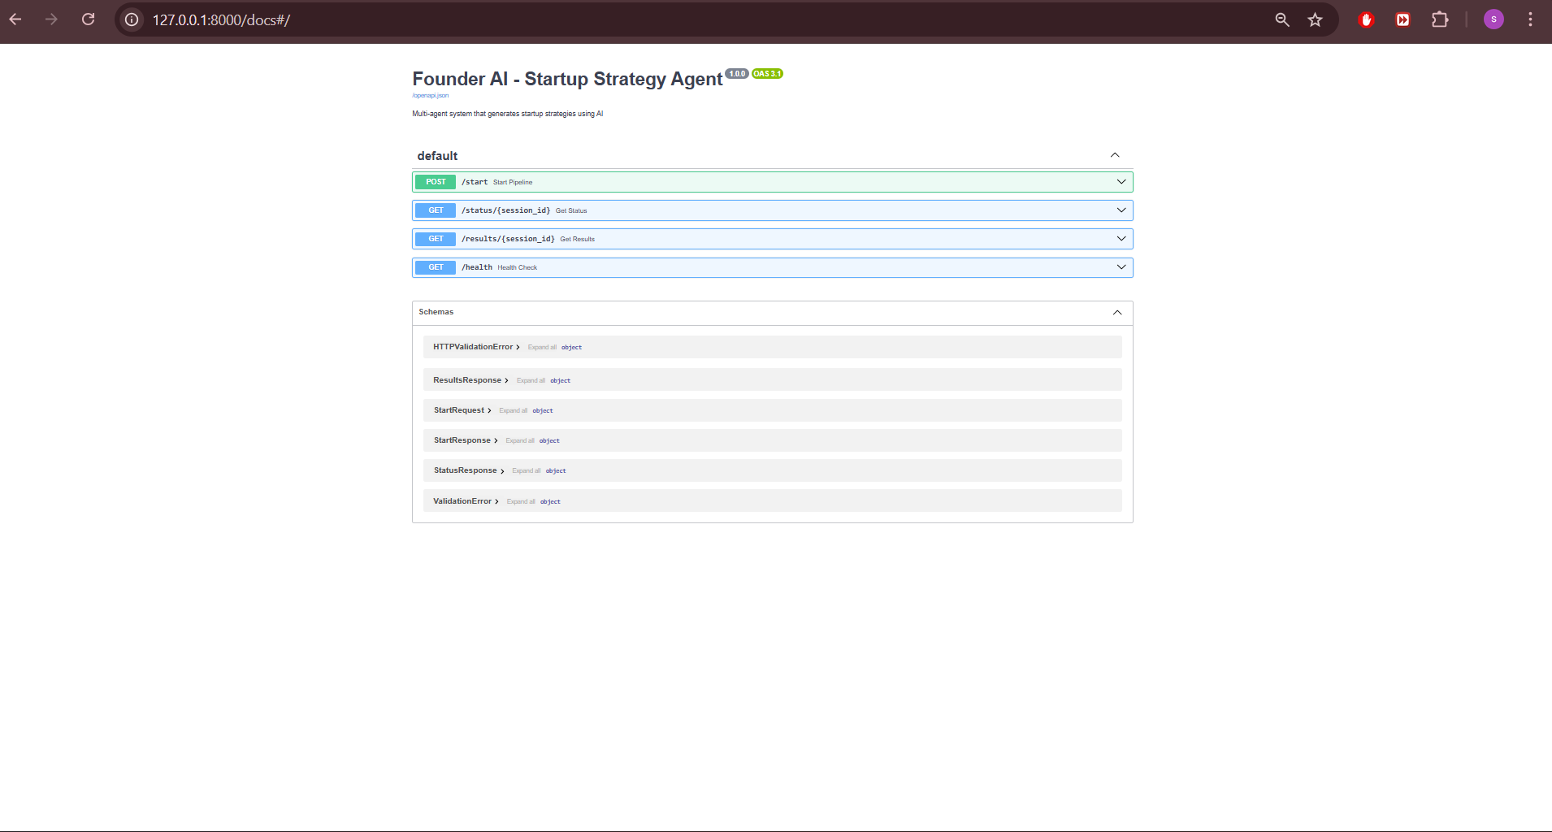
FastAPI Swagger Documentation Interface

Endpoints Created
• /predict-sepsis
• /predict-tumor
• /recommend-treatment
• /history/sepsis
• /history/tumor
• /history/treatment

Logging System
• Configured logging using Python logging module.
• Logs:
- Endpoint hits
- Model version
- Prediction results
- Errors
- Unauthorized access attempts

WORKING OF MY PROJECT
Homepage – Healthcare AI System Dashboard
• This is the main dashboard screen of the AI Healthcare System.
• Users can select different modules from the sidebar:
- Sepsis Prediction
- Tumor Detection
- Treatment Recommendation
- View History
• The system provides a clean, interactive interface for entering patient details and viewing AI predictions.
• This is the entry point before performing any medical prediction or analysis.

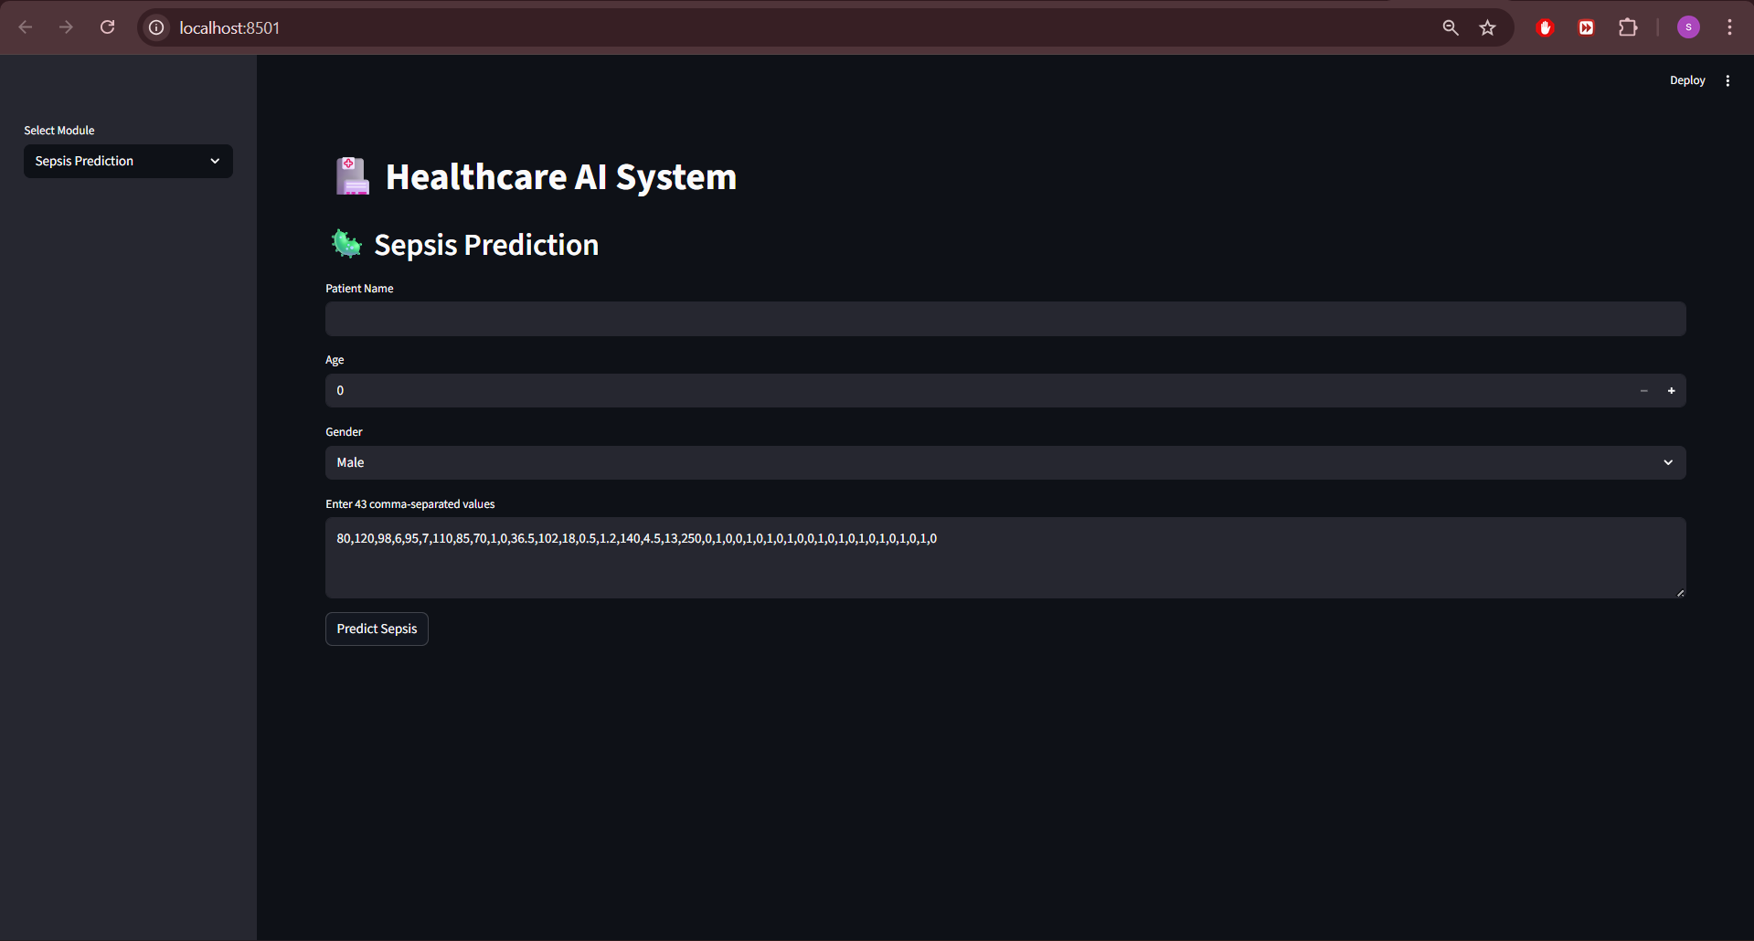
Main Dashboard with Sidebar Navigation

🦠 Sepsis Prediction Module
• This screen allows healthcare staff to enter:
- Patient Name
- Age
- Gender
- 43 clinical feature values
• The entered data is sent securely to the FastAPI backend using the /predict-sepsis API endpoint.
• The trained Machine Learning model evaluates the clinical indicators.
• The system predicts:
- Sepsis Risk (High / Low)
- Probability score (confidence percentage)
• The result is displayed using:
- Colored risk indicator
- Confidence metric
- Visual progress bar
• The prediction is stored in the database for future reference.

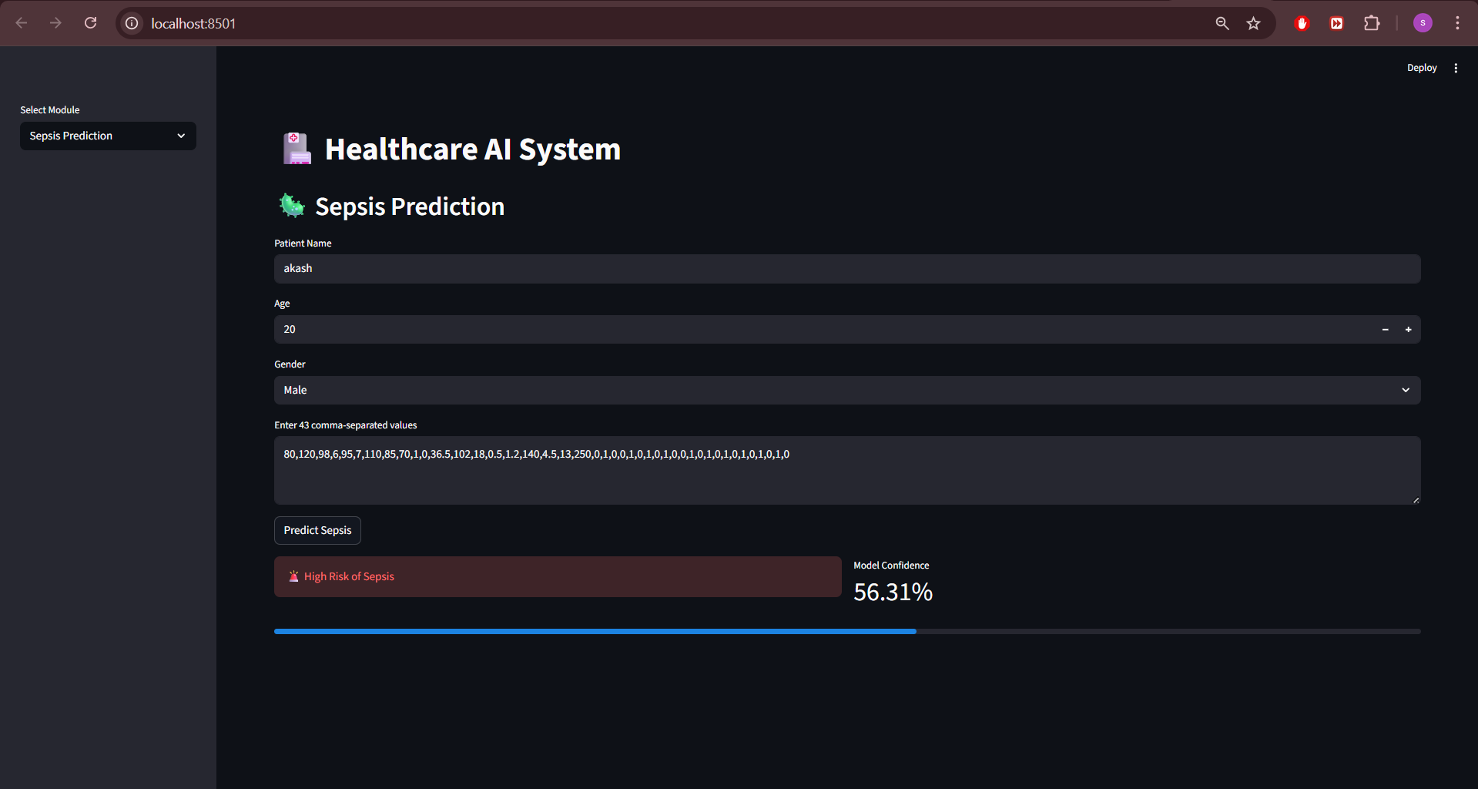
Sepsis Prediction Result with Confidence Score

Tumor Detection Module
• This screen allows users to enter:
- Patient Name
- Age
- Gender
- MRI image path
• The image is processed using a trained Convolutional Neural Network (CNN).
• The system analyzes the MRI scan and predicts:
- Tumor Detected / No Tumor
- Confidence score
• The prediction is displayed clearly with risk indication.
• All tumor predictions are saved in the database with timestamps.


Tumor Detection Output with Confidence

Treatment Recommendation Module
• This module provides severity-based medical guidance.
• The user selects:
- Disease (Sepsis or Tumor)
- Severity level (Low, Medium, High)

• The backend generates:
- Recommended Action
- Treatment Plan
- Urgency Level (Moderate / High / Critical)
• The recommendation follows predefined medical logic for structured guidance.
• All recommendations are stored in the treatment history table.

Treatment Recommendation Output

History Viewer Module
• This module displays previously stored predictions.
• Users can select:
- Sepsis History
- Tumor History
- Treatment History
• The system retrieves records from the SQLite database.
• Displays:
- Patient details
- Prediction result
- Confidence score
- Timestamp
• Enables tracking and monitoring of patient records.


Prediction History Table

CASE SCENARIOS
Case–1: High Sepsis Risk
If the patient shows abnormal clinical indicators such as elevated vitals and abnormal lab values:
• The ML model predicts high probability of sepsis.
• The system displays “High Risk of Sepsis.”
• The progress bar shows elevated confidence level.
• Immediate medical attention is recommended.
Case–2: Tumor Detected in MRI
If the MRI image contains abnormal tumor-like patterns:
• The CNN model detects abnormal tissue.
• Displays “Tumor Detected” with confidence score.
• Supports further radiological evaluation.
Case–3: Severity-Based Critical Treatment
If disease = Sepsis and severity = High:
• System recommends Immediate ICU Admission.
• Displays Critical urgency alert.
• Provides structured treatment plan.
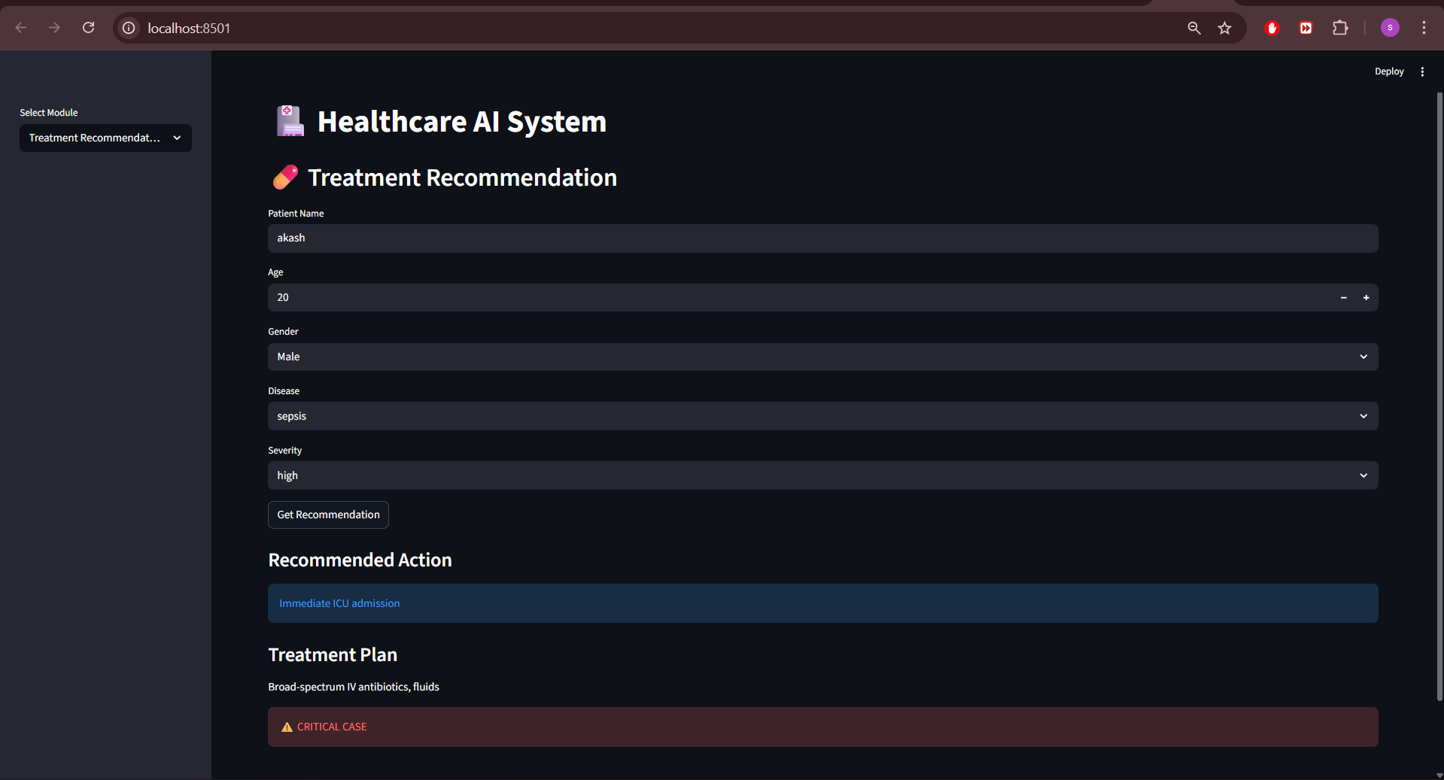 Critical Treatment Recommendation

Backend Working
• FastAPI handles all API requests.
• Implements API key authentication for secure access.
• Loads:
- sepsis_model.pkl
- brain_tumor_model_clean.keras
• Performs real-time prediction.
• Saves results in SQLite database.
• Logs all activities in app.log file for monitoring.
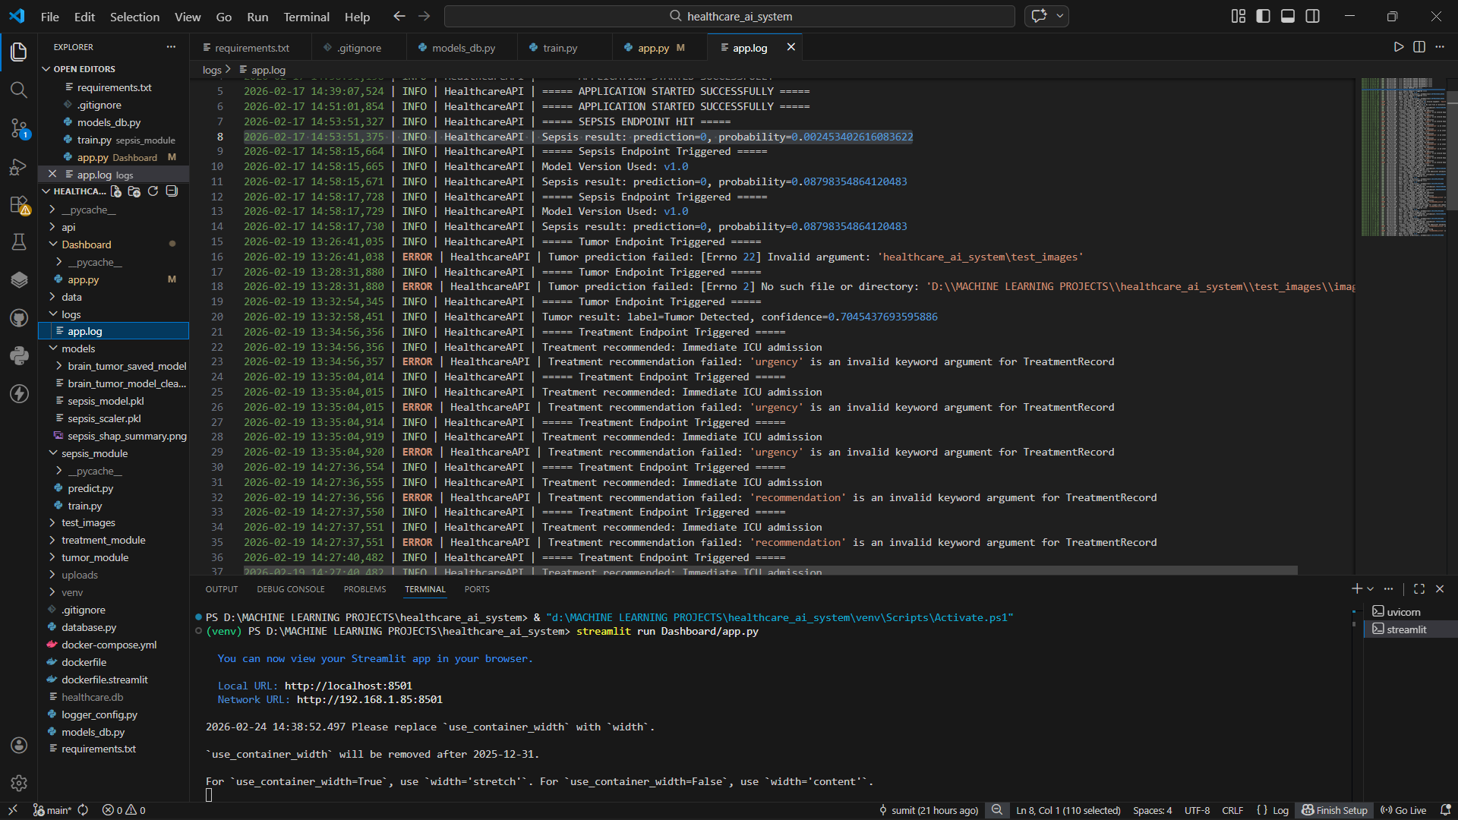
prediction logs

Database Working
• SQLite database stores:
- Patient information
- Prediction results
- Confidence scores
- Treatment recommendations
- Timestamps
-Enables structured patient history management.

GitHub Integration
Finally, the project was successfully uploaded to GitHub for version control and repository management.
The following Git commands were used:
git init
git remote add origin <Repository Link>
git add .
git commit -m "Initial Healthcare AI System Commit"
git branch -M main
git push -u origin main

• The project repository now contains:
- Backend (FastAPI)
- Frontend (Streamlit)
- Models
- Database configuration
- Documentation
